Readlidades 1B
Chaper 5B
Activity 7 page 71

Click on the mp3 link on the LMSpanish.weebly.com (Spanish 1B, Test Preparation, chapter 5B, Descriptions) or go to: http://media.pearsonschool.com/realidades/mp3s/levelB/ch05/LB_c5b_act_3.mp3

Listen to the description of the people. Using the pictures below, determine which description fits which person. The answers are at the bottom of the page, but try not looking at them until you are finished with the activity. There will be one person left over without a description. Write a description of that person that includes hair color and length, height, and one other thing about the person.

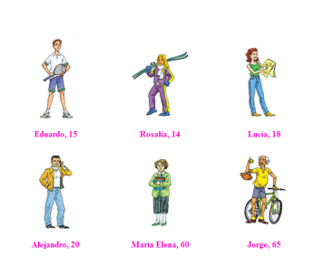

Answers:
- Alejandro
- Jorge
- Rosalia
- María Elena
- Lucia

