Realidades 1B
Chapter 5B
Activity 22

Read the descriptions below and determine which person the descriptions are referring to. The answers are at the bottom of the page, but try not to look at the answers until you have determined who all the people are in the picture.

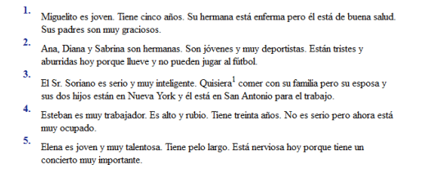
Quisiera = would like

Esteban
Ana, Diana, Sabrina
Elena
Sr. Spriano
Miguelito

