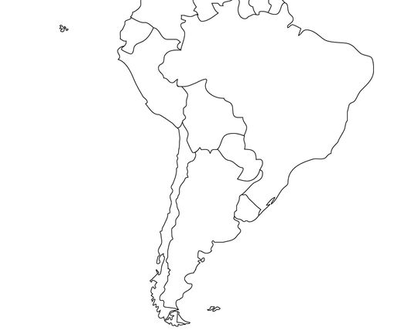
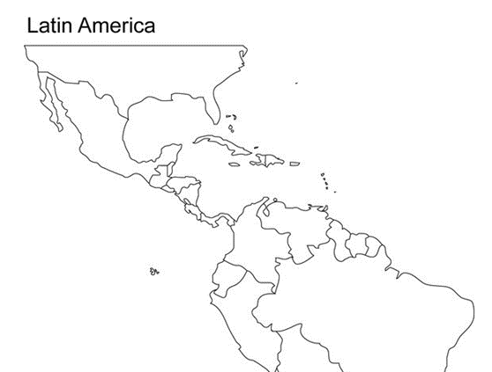

X

What is the one Spanish speaking country Europe?______________________
What is the one Spanish speaking country in Africa?_____________________

