**World Expo**

**Food description template**

**Title**

(Name of food)

**Country:** *(The country you represent)*

**Food:**  *(The official Spanish name of your food)*



**Description:**

*Include:*

* *A definition of what your food is (dessert, drink, main dish, etc.)*
* *What are the main ingredients*
* *When it the food eaten (time of year/day, special occasions, certain area of your country)*

🡪Include a picture that illustrated a traditional version of the food.

🡪Include any additional insights, anecdotes, interesting facts about your souvenir. (See if Wikipedia or any other sight has an interesting write up about your item.)

🡪Include the recipe for your food

**Papa Rellena**

**Country:** Peru



**Souvenir:** Papa Rellena



**Description:**

The Papa Rellena is a ‘stuffed potato’ or mashed potato croquette. It is a main dish and is typically filled with ground beef and spices (onion, garlic, paprika, cumin) and then fried in oil. The Papa Rellena is eaten year round in all parts of Peru and throughout Latin America.

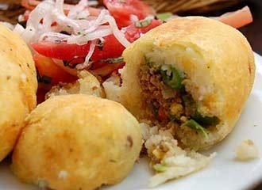

The first printed recipe was from the 19th century when French cuisine was influencing Latin America. The Papa Rellena is very similar to the French croquette.

|  |  |
| --- | --- |
| **Ingredients** Potatoes: 4 pounds Idaho potatoes, peeled and quartered 1/2 cup kosher salt 2 cups warm milk 1 pound unsalted butter, cut in cubes Filling: 1 cup olive oil 2 cups chopped Spanish onion 5 to 6 cloves garlic, chopped | 1 tablespoon toasted ground cumin 1 tablespoon dry oregano 1 tablespoon smoked paprika 1 1/2 tablespoons kosher salt 1/2 tablespoon fresh ground black pepper 1 bay leaf 2 pounds freshly ground beef chuck (85 percent lean to 15 percent fat) 3/4 cup tomato paste 6 to 8 eggs beaten with 1/2 cup milk 4 cups fine panko breadcrumbs 4 cups coarse panko breadcrumbs |