LMS Expo
How to create a pie chart using Google Drive

- Open Google Drive
- Click on the Create button in the upper left corner and select ‘spreadsheet’
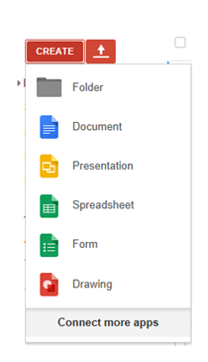
- Entering the Data:
  - In the first column, enter the name of the language or ethnicity.
  - In the second column, enter the percentage of people who speak the language or are of that ethnicity
Example:
Language spoken in Spain
Spanish | 50%
Catalan | 40%
Vasco | 10%

- Create the pie graph
  - Select the ‘Insert’ tab on the top menu:
  - Select ‘chart’
  - Select ‘charts’ on the ‘Chart Editor’ page
  - Choose one of the pie graphs (NOT the donut graph)
- Customize the color and text of the pie graph.
  - Select ‘Customize’ on the Chart Editor page
  - Under ‘title’ type in the name of your chart as either:
‘Percentage of Languages spoken in (country name)’
OR ‘Percentage of Ethnicities in (country name)’
  - Customize the text and color of the title with the available options.
  - Under ‘Legend’ select the drop down menu to decide where the legend will go on the chart
  - Customize the text and color of the legend with the available options.
  - Under ‘Background’ select a color background for your chart.
  - When you are done customizing, click ‘insert’ at the bottom of the Chart Editor page.
- Sharing your chart on Google.
  - Click File and select ‘share’
  - Type a name for your file using either:
‘language graph for (name of country) (your name)’
OR ‘ethnicity graph for (name of country) (your name)’
  - Click ‘share’
  - On the ‘Sharing Settings’ page, place your cursor in the ‘invite people’ box at the bottom and type in: "Leona Hueser" <leona.hueser@bvsd.org>, and "Rebecca Bragg" becky.bragg@bvsd.org
  - Click ‘Share and Save’ and then click ‘done’

