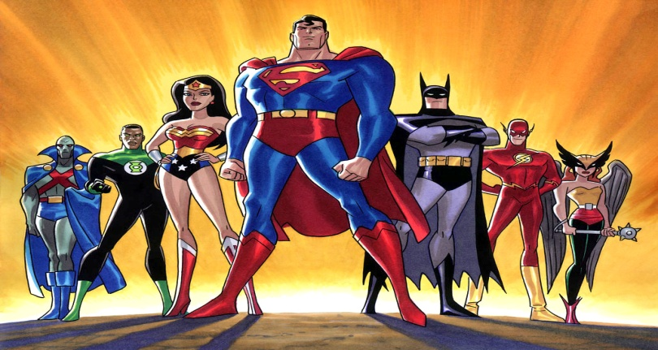
Who?
In groups of no smaller than three and no bigger than four, you are to complete the following unit project.
What is the task?
You are to make up a superhero, villain, or sidekick for the following 12 areas of the human brain.
What would that characters have as their special power and or special weakness if that part of their brain was super. By the end you should have 12 separate characters.

1. Medulla 2. Pons 3. Cerebellum 4. Thalamus 5. Hypothalamus
6. Hippocampus 7. Amygdala 8. Occipital Lobe 9. Temporal Lobe
10. Parietal Lobe 11. Frontal Lobe 12. Corpus Callosum

What will my finished product look like?
You will need the following:
• 12 Character Descriptions that include all of the following
o A name for the character that references the brain area
o Visual(s) (what does the character look like)
o A description of the character’s super powers and/or weaknesses
o The area of the brain used for that character and what it actually controls in the brain
You will put all your characters in a book to be turned in to me on Monday October 29th.

